| **Test Name** | | | Play game | | | |
| --- | --- | --- | --- | --- | --- | --- |
| **Use Case Tested:** | | | Play Game-Play new game registered user | | | |
| **Test Description:** | | | Check that registered user can choose to play a game | | | |
| **Pre-conditions** | | | User must have logged in  Choose game panel must be open | | | |
| **Post-conditions** | | | User can play a new game | | | |
| **Notes:** | |  | | | | |
| **Result (Pass/Fail/Warning/Incomplete)** | | **Pass** | | | | |
|  | **TEST STEP** | | | **EXPECTED TEST RESULTS** | P | F |
|  | Registered user presses game lobby button | | | The game lobby opens | P |  |
|  | User clicks start a new game | | | The category selection screen opens | P |  |
|  | User selects a category for the new game | | | The category shows as the new category | P |  |
|  | User presses start game | | | Game starts with a question and its answers displayed | P |  |

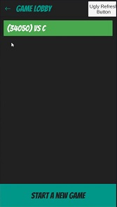

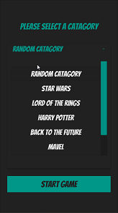

Opens up game lobby Opens category screen Choose a category

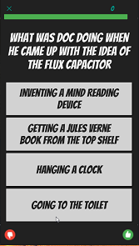

Opens with a question

| **Test Name** | | | Play game | | | |
| --- | --- | --- | --- | --- | --- | --- |
| **Use Case Tested:** | | | Play Game-continue a game | | | |
| **Test Description:** | | | Registered user can continue a game | | | |
| **Pre-conditions** | | | User must be playing as a registered user  Choose game panel must be open | | | |
| **Post-conditions** | | | User can play a new game | | | |
| **Notes:** | |  | | | | |
| **Result (Pass/Fail/Warning/Incomplete)** | | **Pass** | | | | |
|  | **TEST STEP** | | | **EXPECTED TEST RESULTS** | P | F |
| 1 | Registered user presses game lobby button | | | The game lobby opens with open games displayed | P |  |
| 2 | User clicks open game –green button with game details on | | | Category screen displayed with the category of the chosen game | P |  |
| 3 | User presses start game | | | Game starts with a question and its answers displayed | P |  |



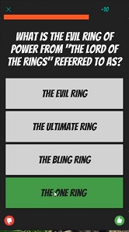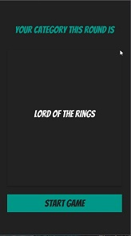

Opens up game lobby Shows category of current game Game opens with a question

| **Test Name** | | | Play game | | | |
| --- | --- | --- | --- | --- | --- | --- |
| **Use Case Tested:** | | | Play Game-play new game guest | | | |
| **Test Description:** | | | Check that guest user can choose to play a game | | | |
| **Pre-conditions** | | | User must be playing as a guest  Choose game panel must be open | | | |
| **Post-conditions** | | | User can play a new game | | | |
| **Notes:** | |  | | | | |
| **Result (Pass/Fail/Warning/Incomplete)** | | **Pass** | | | | |
|  | **TEST STEP** | | | **EXPECTED TEST RESULTS** | P | F |
| 1 | Guest user presses new presses game lobby | | | Game lobby opens | P |  |
| 4 | Press start a new game | | | Category screen opens | P |  |
| 3 | Choose a category | | | Shows chosen category | P |  |
| 4 | Press start game | | |  | P |  |

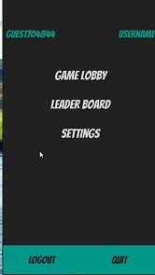

Guest menu Game lobby Chosen category



Game opens with a question

| **Test Name** | | | Play game | | | |
| --- | --- | --- | --- | --- | --- | --- |
| **Use Case Tested:** | | | Play game-Answer question | | | |
| **Test Description:** | | | This test should make sure a user can answer a question | | | |
| **Pre-conditions** | | | User must have chosen either a pre-existing game or a new game  Game screen must be open | | | |
| **Post-conditions** | | | User should be able to answer a question | | | |
| **Notes:** | |  | | | | |
| **Result (Pass/Fail/Warning/Incomplete)** | | **Pass** | | | | |
|  | **TEST STEP** | | | **EXPECTED TEST RESULTS** | **P** | **F** |
| 1 | User reads displayed question and chooses answer | | | User should be able to select an answer | **p** |  |

|  |  |  |  |  |  |
| --- | --- | --- | --- | --- | --- |
| **Test Data Table** | | | | | |
|  | **1** | **2** | **3** | **4** | **5** |
| Doc was shot in the back because of how much money | 80 | 75 | 50 | 100 |  |

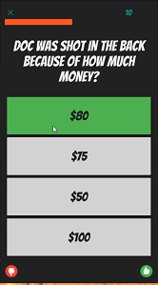

Showing correct answer as green and score of 10

| **Test Name** | | | Answer question | | | |
| --- | --- | --- | --- | --- | --- | --- |
| **Use Case Tested:** | | | Answer question- Correct answer | | | |
| **Test Description:** | | | Verify that answering a question correctly adds points to players score | | | |
| **Pre-conditions** | | | User must have chosen either a pre-existing game or a new game  Game screen must be open | | | |
| **Post-conditions** | | | Players score should increase 10 points every correct answer | | | |
| **Notes:** | |  | | | | |
| **Result (Pass/Fail/Warning/Incomplete)** | | **Pass** | | | | |
|  | **TEST STEP** | | | **EXPECTED TEST RESULTS** | **P** | **F** |
| 1 | Player answers question correctly | | | 10 points will be added to players score and answer button turns green | **p** |  |

|  |  |  |  |  |  |
| --- | --- | --- | --- | --- | --- |
| **Test Data Table** | | | | | |
|  | **1** | **2** | **3** | **4** | **5** |
| Old man Peabody had a crazy idea about what? | Breeding pine trees | Time travelling | Building a shopping mall | Starting a fish farm |  |
| Doc was shot in the back because of how much money | 80 | 50 | 100 | 75 |  |

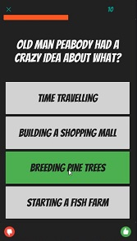

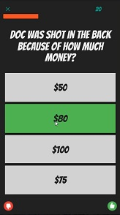

Shows correct answer with score 10 Shows correct answer with score 20

| **Test Name** | | | Play game | | | |
| --- | --- | --- | --- | --- | --- | --- |
| **Use Case Tested:** | | | Answer question- Incorrect answer | | | |
| **Test Description:** | | | Verify that answering a question incorrectly subtracts points from players score | | | |
| **Pre-conditions** | | | User must have chosen a new game  Game screen must be open | | | |
| **Post-conditions** | | | Players score should decrease 5 points every incorrect answer | | | |
| **Notes:** | |  | | | | |
| **Result (Pass/Fail/Warning/Incomplete)** | | **Pass** | | | | |
|  | **TEST STEP** | | | **EXPECTED TEST RESULTS** | **P** | **F** |
| 1 | Player answers question incorrectly | | | 5 points will be decreased from players score and wrong answer turns red with correct answer being shown to player by turning green | **P** |  |

|  |  |  |  |  |  |
| --- | --- | --- | --- | --- | --- |
| **Test Data Table** | | | | | |
|  | **1** | **2** | **3** | **4** | **5** |
| What is the password to enter the doors of Durin | Friend | Mayday | Gravest need | I come in peace |  |

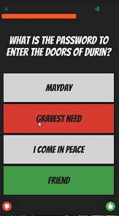

Wrong answer shown red -5 points   
score and correct answer shown in green

| **Test Name** | | | Play game | | | |
| --- | --- | --- | --- | --- | --- | --- |
| **Use Case Tested:** | | | Play round-Timer stops round | | | |
| **Test Description:** | | | Verify that round timer works | | | |
| **Pre-conditions** | | | User must have chosen either a pre-existing game or a new game  Game screen must be open | | | |
| **Post-conditions** | | | Timer bar should decrease till time runs out | | | |
| **Notes:** | |  | | | | |
| **Result (Pass/Fail/Warning/Incomplete)** | | **Pass** | | | | |
|  | **TEST STEP** | | | **EXPECTED TEST RESULTS** | **P** | **F** |
| 1 | Question should be displayed with answers | | | Timer bar at top should decrease till no time left and stop round | **P** |  |



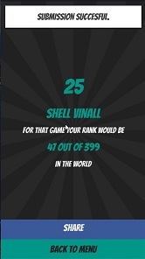

Timer bar green nearly full Timer bar less and turned red Timer ran out end of round screen displays

| **Test Name** | | | Play game | | | |
| --- | --- | --- | --- | --- | --- | --- |
| **Use Case Tested:** | | | Play round-Submit score | | | |
| **Test Description:** | | | Verify that score is submitted at the end of rounds and game | | | |
| **Pre-conditions** | | | User must finish a round or game  Game screen must be open | | | |
| **Post-conditions** | | | Score should be submitted to database. | | | |
| **Notes:** | | **Database did not update score** | | | | |
| **Result (Pass/Fail/Warning/Incomplete)** | | **First run Fail** | | | | |
|  | **TEST STEP** | | | **EXPECTED TEST RESULTS** | **P** | **F** |
| 1 | User finishes a round and score submits to database if it is the users highest score | | | Score should be submitted to the database. |  | **F** |
|  |  | | |  |  |  |
| 1 | User finishes a round and score submits to database if it is the users highest score | | | Score should be submitted to the database. |  |  |



Screen showing that score was   
 successfully submitted

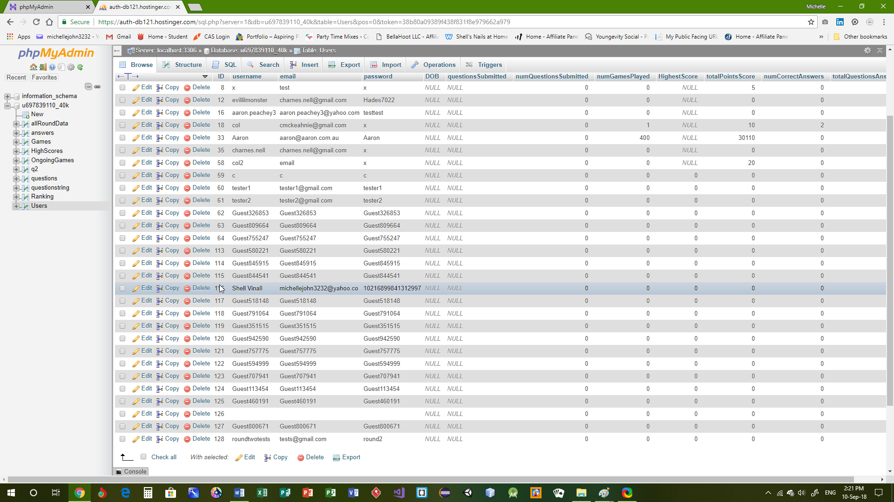

Score not added to database score column showing 0 should say an amount.